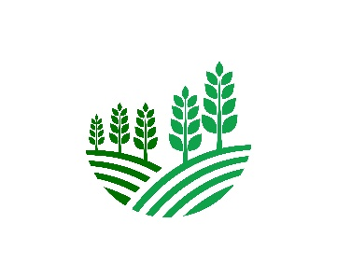 **TEAM HACKADEMICS**

**ENVISION 2k25**

**Problem Statement :- Crop Yield Prediction**

**Description: Use agricultural datasets (soil quality, weather conditions, crop type) to predict crop yield and recommend agricultural practices for optimization.**

**Data Collection strategy:**

As per the dataset we require a dataset that is suitable for both prediction and recommendation.

**For predicting crop yield** we need various features like

* area
* type of crop
* units of production
* location of crop
* production

**For recommendation we require**

* factors affecting soil(like Nitrogen,Phosphorous,Potassium)
* temperature
* humidity
* pH
* rainfall
* label(type of crop)

**Data Sources:**

Website:

Affiliate link by data.gov.in

By Opensource Government data platform , Govt. of India(using api)

**LINK:** [**District-wise, season-wise crop production statistics from 1997 | Open Government Data (OGD) Platform India**](https://www.data.gov.in/resource/district-wise-season-wise-crop-production-statistics-1997)

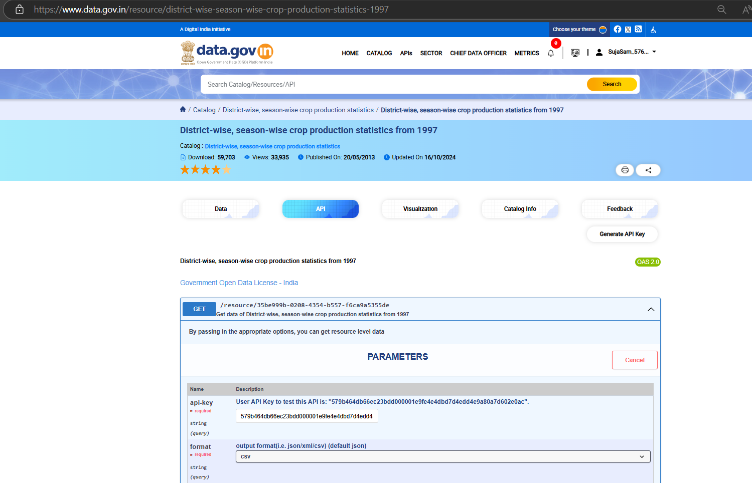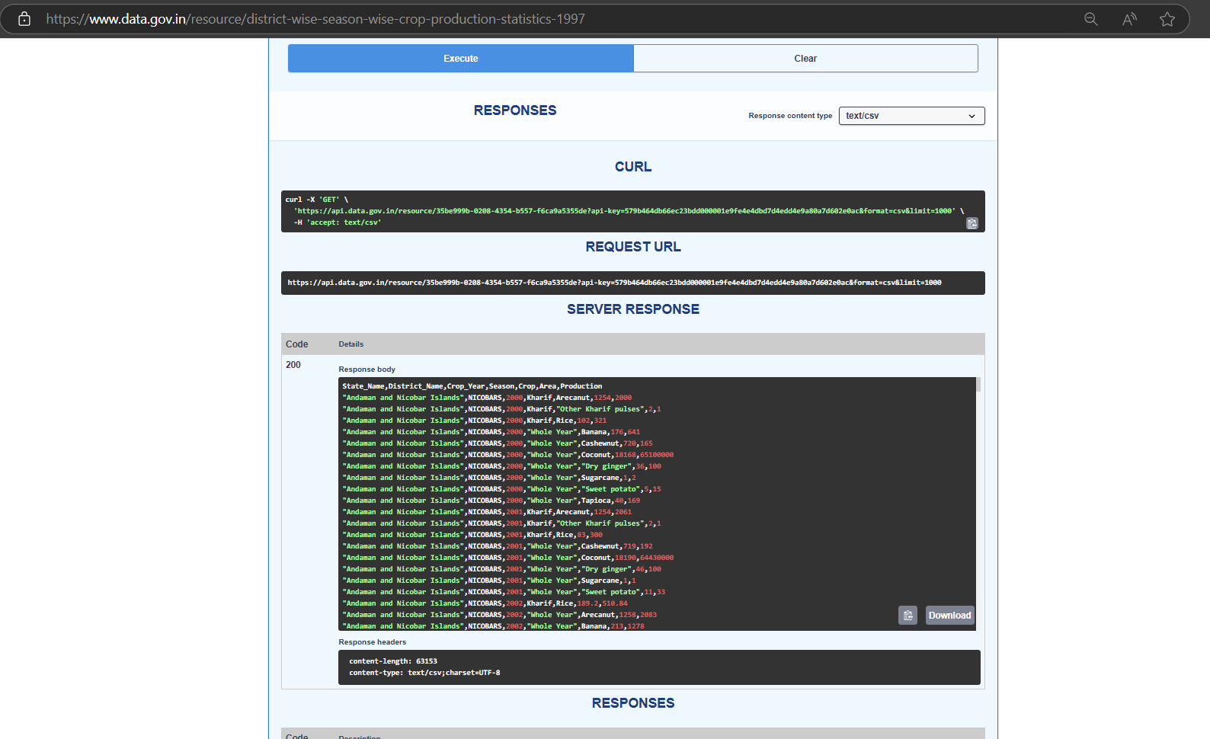

**Herein we have extracted/scraped data by using API provided by the website .**

**The site also offers direct .csv for the data.**

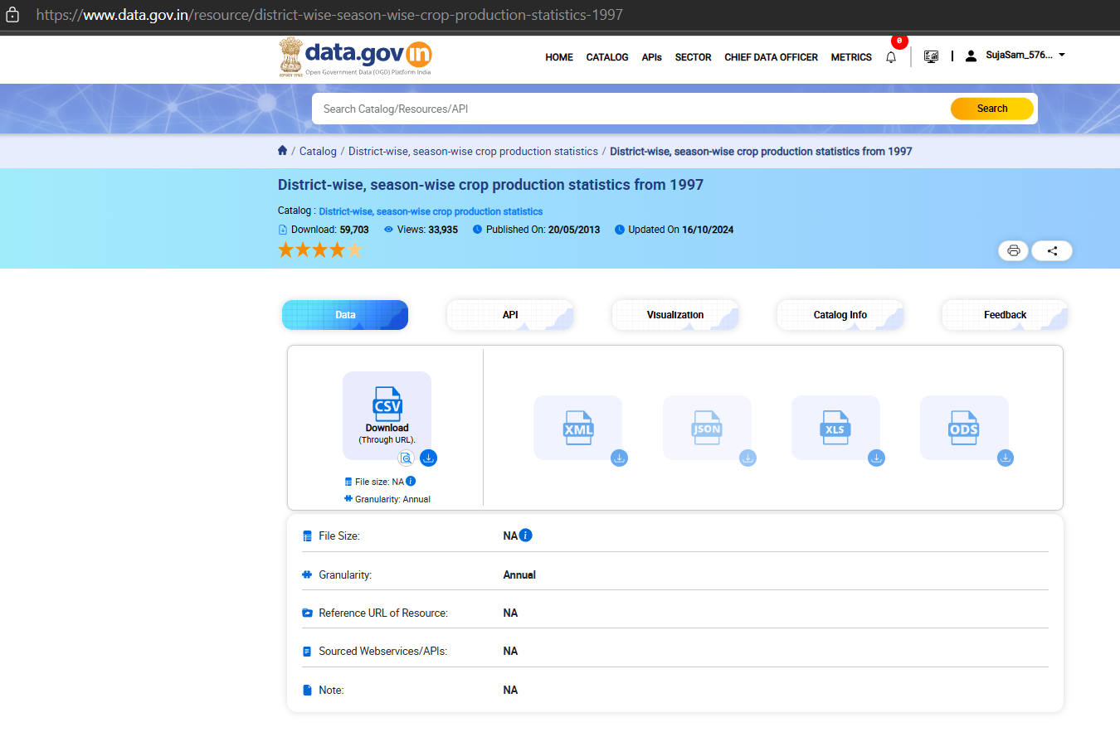

**We can scrap data from this government site very efficiently it provides crisp and accurate data about crop production and their yield depending on environmental factors , location and seasons.**

**Area and production statistics**

BY MINISTRY OF AGRICULTURE AND FARMERS WELFARE

Govt. Of INDIA

[Area Production Statistics](https://aps.dac.gov.in/Home.aspx?ReturnUrl=%2f)

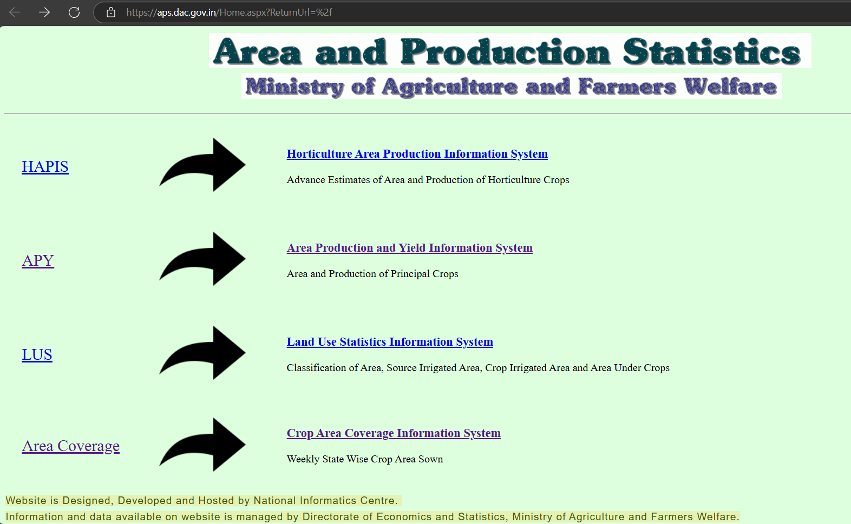

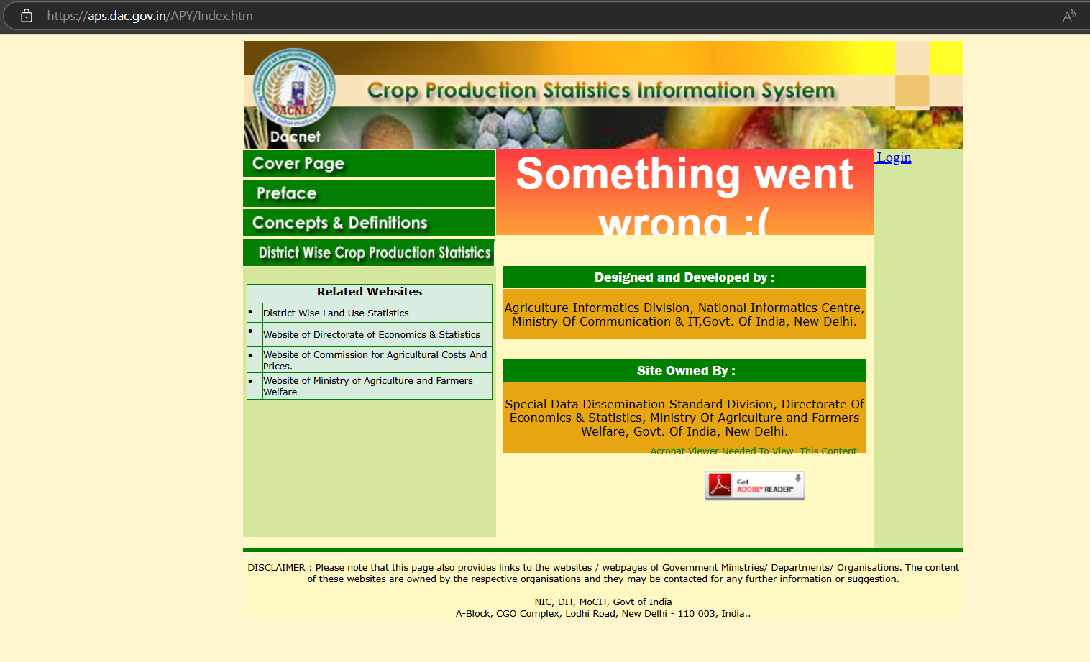

Affiliate link by data.gov.in

By Opensource Government data platform , Govt. of India

**LINK:** [**District-wise, season-wise crop production statistics from 1997 | Open Government Data (OGD) Platform India**](https://www.data.gov.in/resource/district-wise-season-wise-crop-production-statistics-1997)

**DATASET DESCRIPTION**

The dataset is provided by Govt. of India and can be assessed using

**Link:** [**District-wise, season-wise crop production statistics from 1997 | Open Government Data (OGD) Platform India**](https://www.data.gov.in/resource/district-wise-season-wise-crop-production-statistics-1997)

The shape of dataset is 246092 x 7

It contains 246092 rows and 7 columns

The size of the dataset makes it EXCELLENT for model development

The dataset set has data over the year from 1997- till date

**The row/features of the dataset are**

**State** (name of state)

**District** (name of District)

**Crop year** (year of cultivation)

**Season** (season Kharif/Rabi/Autumn/Whole year/Summer/winter)

**Crop**(crops like banana, sugarcane ,rice, etc)

**Area**(Area of cultivation)

**Production**(Production in tonnes)

